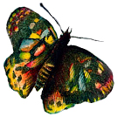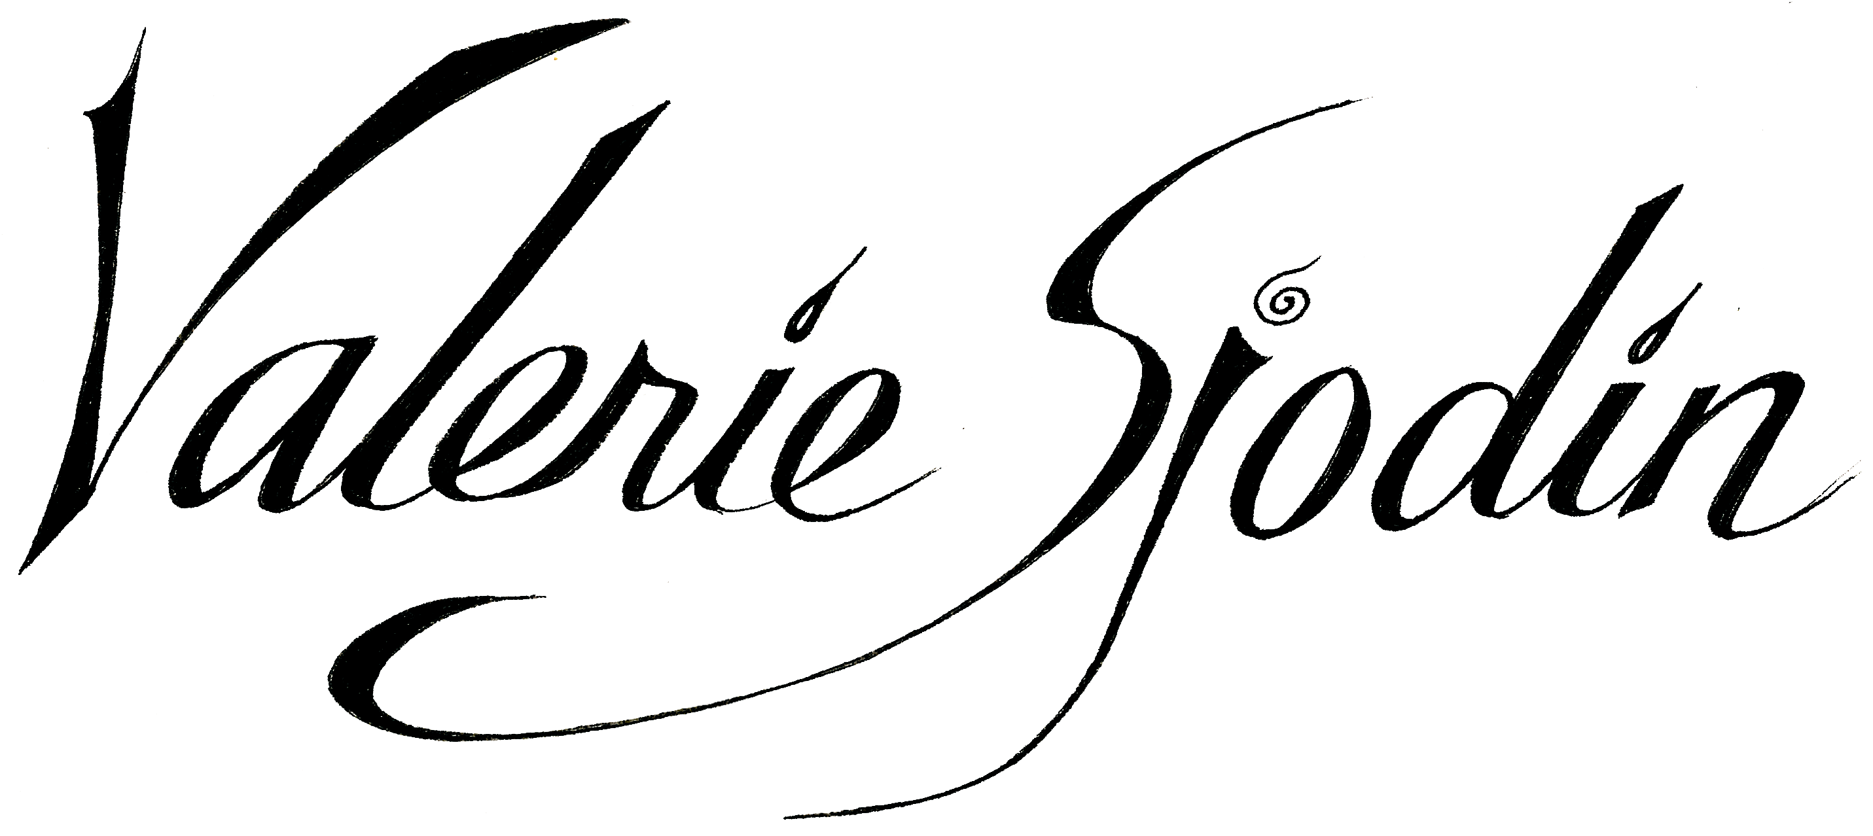
Artist & Workshop Facilitator

Hillsboro Oregon 97124

valerie@valeriesjodin.com

www.valeriesjodin.com

RESUME PROFILE

Art journaling has become a natural part of my life journey. For me, it is a way to chronicle life’s journey, through problem solving, improving self-talk, deepening meaning and purpose. Other times it is just plain fun. I love teaching ways of art journaling and sharing in the “aha” moment with people. I believe in sharing our stories, that we are each a biography within the big Story – an adventurous mystery, romance, tragedy, comedy, or poem. Life is about how our stories weave in and out of one another’s, how they are passed on, and what makes them special. Art journaling is a beautiful, visual way to participate in that journey that is “all about relationships.” I enjoy connecting with people, creating a safe place for them to express themselves and helping them develop their own visual expression.

SKILLS

- Inspire people to believe in their creative ability and process through encouragement, demonstrations, showing examples, and breaking the creative process down into doable steps
- Relate well to people of various ages, in a variety of situations
- Have a variety of art skills due to my personal practice, and taking many art workshops and teaching art techniques
- Communicate art skills verbally and visually, having years of experience showing how to do art techniques
- Walk the talk of living the benefits of Art Journaling and am enthusiastic about sharing those benefits with others

PROFESSIONAL EXPERIENCE

Art Workshop Facilitator, 2007 - Current

I am a professional working Artist and Workshop Facilitator living and working in Hillsboro, Oregon.

As a Teacher I am active in:

- Teaching art journaling and related workshops in my studio
- Teaching customized art journaling and visual prayer activities/workshops to accommodate specific groups such as: Rock Creek Community Church, RCC women’s retreat, George Fox graduate class, Saanich Community Church in Victoria BC, Creative Church Conference in Boise Idaho, Universalist Creative Group, First Presbyterian Church of Hillsboro Mother’s Day tea, and in more private groups for creative gatherings or birthday celebrations
- Teaching online art journaling workshops www.valeriesjodin.com

As an Artist and Writer I am active in:
- Blog writing: http://visualblessings.blogspot.com/
- Art journaling
- Painting: acrylic and mixed media painting, commission painting
- Working on a how-to Art Journaling book: Prayerful Doodling

Art Teacher/High School and Jr. High, 1999-2009

Heritage Christian School, Hillsboro, Oregon

- Taught Art and Art History to high school and junior high students
- Developed a successful integrated art program with Jr. High and High School Humanities teachers, and Jr. High Science teachers, integrating what was being learned in their classes with relevant art projects that taught art skills.
- Presented bi-annual art exhibits of student artwork

VOLUNTEER EXPERIENCE & COMMUNITY INVOLVEMENT

- Open Studio with art demos and public participation 2016
- How-to-Color mini-workshop at local library 2016
- Lifetime Arts Creative Aging 8-week workshop: Capturing Your World in Watercolor and Pen 2015
- Participating Artist for four years in Washington County Artists Open Studios, 2011- 2015. We open our studios to the public the 3rd weekend of October.
- Website volunteer for Washington County Artists Open Studios, 2012-2013
- Local Art Exhibit involvement include: North Plains Library, 2012; Walters Cultural Center, 2009
- Art Literacy teaching volunteer at Jackson Elementary School, Hillsboro, Oregon, 1996-2000

EDUCATION

- Bachelor of Fine Arts in Painting, 2005

Marylhurst University, OR

- I have attended numerous workshops. There are a few that stand out as inspirational and helpful: Susan Sarback with the School of Light & Color, Jonathan Talbot’s on Collage, and Artfest 2006

PUBLISHED IN

Art Journaling Magazine, Autumn 2013

Artist’s Café 2013, Volume 7-Best of Mixed Media

Art Journaling Magazine Summer 2013

Somerset Studio Sept./Oct. 2011

Art Journaling Magazine Winter 2011

BOOKS PUBLISHED

Colorful Blessings coloring book, Taunton Press 2/2016

Colorful Blessings~Celebrating Everyday Wonders, Taunton Press 6/2016

Paintings, Prayers & Passages, an illuminated journdy 2011

